##### A Project report on

**VOCABULARY TUTOR**

###### A Dissertation submitted to JNTU Hyderabad in partial fulfillment of the academic requirements for the award of the degree.

**Bachelor of Technology**

**in**

**Computer Science and Engineering**

Submitted by

**Batch - 92**

**19H51A05P0 - MOIN ASHIQ**

**19H51A05N8 - M. MOUNIKA**

**19H51A05N6 – K. JAI SANTOSH BABU**

Under the esteemed guidance of

**M. KAMALA**

(Assistant Professor)



**Department of Computer Science and Engineering**

**CMR COLLEGE OF ENGINEERING AND TECHNOLOGY**

(An Autonomous Institution under UGC & JNTUH, Approved by AICTE, Permanently Affiliated to JNTUH, Accredited by NBA.)

KANDLAKOYA, MEDCHAL ROAD, HYDERABAD - 501401.

#### 2019- 2023

**CMR COLLEGE OF ENGINEERING & TECHNOLOGY**

KANDLAKOYA, MEDCHAL ROAD, HYDERABAD – 501401

**DEPARTMENT OF COMPUTER SCIENCE AND ENGINEERING**

#### CERTIFICATE

This is to certify that the Mini Project-1 report entitled **"VOCABULARY TUTOR “being** submitted by **Moin Ashiq(19H51A05P0), Madham Mounika(19H51A05N8), Katta Jai Santhosh Babu(19H51A05N6)** in partial fulfillment for the award of **Bachelor of Technology in Computer Science and Engineering** is a record of Bonafide work carried out his/her under my guidance and supervision.

###### The results embody in this project report have not been submitted to any other University or Institute for the award of any Degree.

M. Kamala Dr. K Vijaya Kumar

Asst.Professor Professor and HOD

**Dept. Of CSE Dept. Of CSE**

**TABLE OF CONTENTS**

|  |  |  |  |
| --- | --- | --- | --- |
| **CHAPTER**  **NO.** | **TITLE** | | **PAGE NO.** |
|  | **LIST OF FIGURES** | | 1 |
|  | **LIST OF TABLES** | | 1 |
|  | **ABSTRACT** | | 2 |
| **1** | **INTRODUCTION** | | 3 |
|  | 1.1 | Need statement | 4 |
|  | 1.2 | Objective, Scope & Limitations | 4 |
|  |  | 1.2.1 Objective | 4 |
|  |  | 1.2.2 Scope | 4 |
|  |  | 1.2.3 Motivation behind selection of the project | 4 |
|  |  | 1.2.4 Limitations | 4 |
| **2** | **BACKGROUND WORK** | | 5 |
|  | 2.1 | Introduction | 5 |
|  | 2.2 | Literature survey | 5 |
|  | 2.3 | Existing solutions | 6 |
| **3** | **PROPOSED SYSTEM** | | 7 |
|  | 3.1 | Introduction | 7 |
|  | 3.2 | Theoretical/ Conceptual framework | 7 |
|  |  | 3.2.1 Hardware Requirements | 8 |
|  |  | 3.2.2 Software Requirements | 8 |
|  | 3.3 | Advantages | 8 |
| **4** | **DESIGNING** | | 9 |
|  | 4.1 | Preliminary Design | 9 |
|  |  | 4.1.1 UML Diagrams | 9 |
|  |  | 4.1.2 Activity Diagrams | 10 |
|  | 4.2 | Data control Design | 11 |
| **5** | **RESULTS AND DISCUSSION** | | 12 |
|  | 5.1 | Implementation | 12 |
|  | 5.2 | Result | 16 |
| **6** | **CONCLUSION AND FUTUREWORK** | | 18 |
|  | 6.1 | Conclusion and Future work | 18 |
|  | 6.2 | References | 18 |

## List of Figures

|  |  |  |  |
| --- | --- | --- | --- |
| **TABLE NO.** | **CHAPTER**  **NO.** | **TITLE** | **PAGE**  **NO.** |
| 1 | 3.2.1 | Theoretical/Conceptual Framework | 7 |
| 4 | 5.2.2 | Icon of Application | 16 |
| 5 | 5.2.3 | Final Terminal of Vocabulary Tutor | 16 |
| 6 | 5.2.4 | Resultant POP out | 17 |

# **List of Tables**

|  |  |  |  |
| --- | --- | --- | --- |
| **TABLE NO.** | **CHAPTER**  **NO.** | **TITLE** | **PAGE**  **NO.** |
| 1 | 4.1.1 | Use Case diagram | 9 |
| 2 | 4.1.2 | Activity diagram | 10 |
| 3 | 4.2 | Data Control Flow diagram | 11 |

**ABSTRACT**

The main aim of the project is to develop English Vocabulary of users. This project allows the user to set timer and after specified time a popup will appear at desktop notification showing and English word and its meaning. If the timer is set to one hour, then after every one hour an English word and the meaning of the word will pop-up at desktop notification. In this way while working on Desktop or laptops one can open this application and set the timer so that they can learn new words and their meaning.

# **CHAPTER 1**

# **INTRODUCTION**

* English language plays an essential role in our lives as it helps in communications. It is the main language for studying any subject all over the world. English is important for students as it broadness their minds, develops emotional skills, improve the quality of life by providing job opportunities.

**Why vocabulary is important?**

* Learners can express themselves better.
* Knowing more words allows a learner to choose their words more precisely and so become more effective and accurate when communicating with others.
* It empowers learners academically.
* Students need vocabulary instruction that allow them to build rich representation of words.

So, developing an application Vocabulary Tutor which is very useful to improve vocabulary skills. In this digital world many people use laptops, desktops, tabs, etc. So, while they are working on the computer they can switch to this application and set the timer so that after every specified time the application pops up a notification with an English word and its meaning. In this way one can learn new words and their meanings while they are working on computers, laptops, etc.

## 1.1Need Statement

## Develop an application which helps in learning new vocabulary, which will increase the communication skills of user by learning new words every day while they are working on computers, laptops etc...

## 1.2 Objective, Scope & Limitation

## *1**.2.1 Objective*

* Dynamic model.
* It doesn’t access internet.
* It can be useful for everyone.
* Timer can be specified by user.
* Voice module is also helpful.
* Infinite number of words can be learned daily without any limitations & no repeated words.

**1.2.2 Scope**

Our project mainly covers these operations: Creating an application to learn new words daily with voice module. Timer will help the user to know the new words time to time. It doesn’t require internet. So that even there is a power cut in our house user can learn new words. Daily user can learn new words without any limitations. The words are not repeated.

**1.2.3 Motivation behind selection of the project**

The main motivation for selecting this project is, it is particularly useful to develop our Vocabulary skills. As we know English is an important language to communicate with the people from different states, countries, etc., it is important to use good vocabulary to express ourselves. And in the busy life many people don’t get time to focus on development of their vocabulary. So we developed this application which is helpful to learn new words every day. Now a days Many of us work on desktop, laptops, etc. so while working on them we can switch to this app and can set the timer. And after every specified time it will notify with an English word and its meaning. In this way one can learn new words every day and can implement them while communicating with others which will be very helpful.

## 1.2.4 Limitations

* It is not applicable in android.
* User cannot access previous words in this application.

**CHAPTER 2**

**BACKGROUND WORK**

## 2.1 Introduction

This section discusses findings and observations done by some research works on web-based chat room.

## 2.2 Literature survey

1. The background of the study in this research is based on the phenomenon that students have difficulties in learning English vocabulary because the teacher teaches the vocabulary without being supported by teaching aids. The result is the students’ ability to learn is slow. To improve students’ ability in learning English vocabulary, teacher needs a strategy through using an aid that facilitates the students. Realia is one the aid that can be used in teaching English vocabulary. Using realia, students are able to learn English vocabulary easily. This research is aimed at finding the answers to the research questions and to achieve the objectives. This research is conducted in a classroom of a private school. With the help of Kempis and McTaggart model of research the data was collected and analyses mathematically. The students were motivated with the use of realia. They gave full attention to teacher’s explanation and showed great interest in learning new vocabulary. Finally, the result of this research shows that students’ ability was improved after they were taught using realia. They were better in learning vocabulary.
2. As long as English is still the language of science, technology, international business, research, and academic publication, strategies on how to teach and learn the English language effectively continue to be a subject of great interest among English teachers and learners, and perhaps effective English learning and teaching strategies will remain a popular topic of discussion and research for years to come. Given the significance of having extensive vocabulary knowledge, that is, knowing a lot of English words, particularly high frequency ones, many, if not all, English as a second or foreign language learners from all over the world may have a strong interest in knowing and understanding how English vocabulary can be learned in an effective way. To provide English learners, especially Cambodian English learners, with some ideas on how to learn English vocabulary effectively, this short article presents learning strategies believed to be effective for learning English vocabulary. The ideas presented in this essay are based on research findings drawn from the author's unpublished master's thesis conducted about 10 years ago. Although the research on which this article is based is relatively old, its findings

are still highly relevant and applicable to the current context of English language learning in Cambodia and beyond.

**Existing solutions**

There are two existing android applications that offer teaching English Vocabulary opportunity to the users to improve his /her English Skills. Both app has different features. The existing solutions are: -

* Learn vocabulary with wozzol.
* Vocabulary.com

**Learn vocabulary with wozzol**

Wozzol is one of the most comprehensive vocabulary apps available that aims at helping people, with a good understanding of the English language, the ability to continue to improve your vocabulary. This app is super helpful if you need help with improving your vocabulary. This app allows you to either learn and retain words you choose or words the app chooses for you.

**Demerits:**

* Not a dynamic app.
* It is applicable only in androids, iphones & ipods.
* This app is applicable only for: - Primary School & secondary school students.
* Access Internet

**Vocabulary.com**  
Vocabulary.com mobile app is the fastest, easiest way to learn vocabulary. This is the vocabulary app that grows with you and also helps you memorize words. Users move through a series of quick questions to determine their level, and Vocabulary.com can cater a list of fit their abilities. You can also choose from over 50,000 pre-made lists.

**Demerits:**

* Not a dynamic app.
* It is applicable only in androids.
* This app is applicable only for: - Secondary school students.
* Access Internet.

**CHAPTER 3**

**PROPOSED SYSTEM**

## 3.1 Introduction

This section presents the research methodology used in the study, the research design, and the data collection process.

**3.2 Theoretical/ Conceptual Framework**



Fig 3.2.1

* To start with the console was designed first which takes two inputs from user the name and timer.
* Submit and exit buttons are added to console to accept data and to stop the process or to exit the application.
* A function is then designed to hold the parameters which are passed from the console.
* A datasheet is then designed to hold words and meanings.
* The function then accesses to the data sheet and takes one word and its meaning.
* Voice modules are then added which takes the user’s name and pronounce that during notification popup.
* Then multithreading is implemented to handle waiting process.
* Icon file is also added which will be displayed during notification time.
* To convert this code file to an executable we installed py installer and added all modules to that.
* The data flow that are mentioned above are shown in the below diagram.

## 3.2.3 Hardware Requirements

Laptop and Desktop

## 3.2.4 Software Requirements

## We would like to use python *& its libraries and MS Excel to* develop this project.

## Required installation modules:

## tkinter

## pyttsx3

## plyer

## openpyxl

## inflect

## pyqt5

## 3.3 ADVANTAGES

* Dynamic model.
* It doesn’t access internet.
* It can be useful for everyone.
* Timer can be specified by user.
* Voice module is also helpful.
* Infinite number of words can be learned daily without any limitations & no repeated words.

## CHAPTER 4

## DESIGNING

## 4.1 Preliminary design

Tools, which assist in preliminary design process, are UML Diagrams and ER diagrams.

## *4.1.1 UML Diagrams*

1. Use-case Diagram:

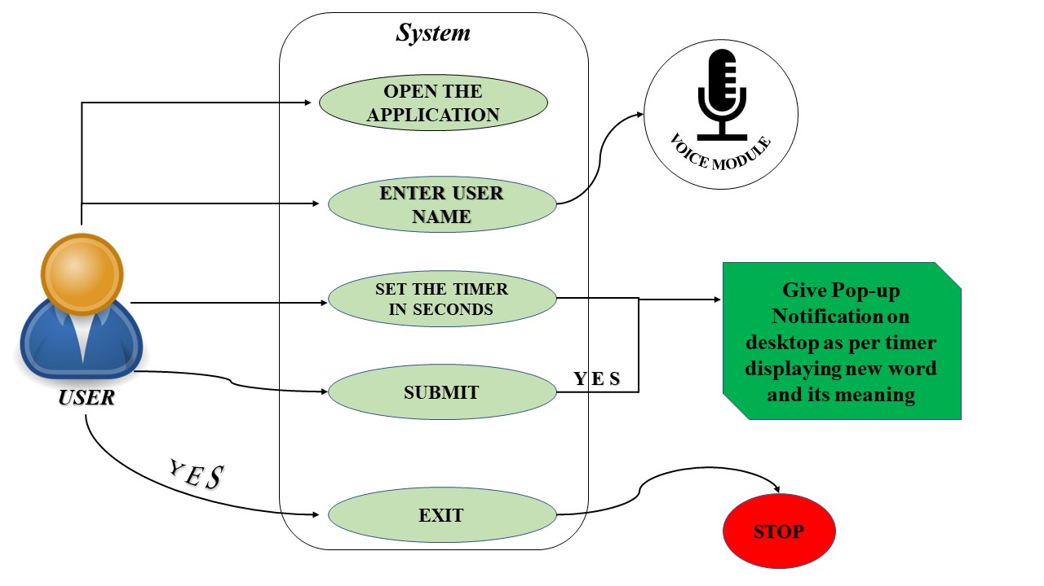 ii. Activity Diagram

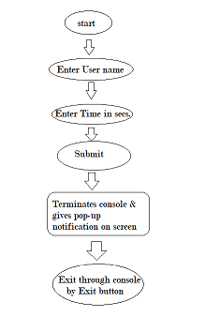

## 4.2 Data Control Flow Design:

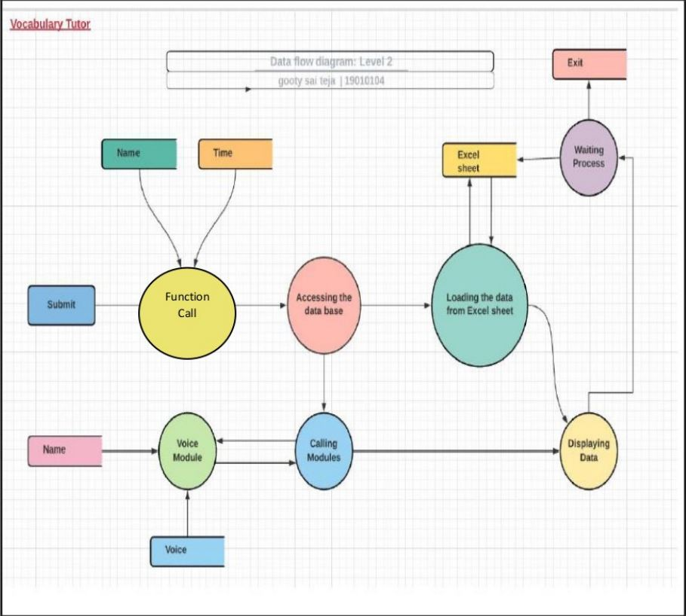

**VOCABULARY TUTOR**

## CHAPTER 5:

## RESULTS AND DISCUSSION

## 5.1 Implementation:

## 5.1.1 Main Code

## Modules

import pyttsx3

from plyer import notification

import time

import openpyxl

import inflect

from tkinter import *

from PyQt5.QtCore import QObject, QThread, pyqtSignal

import threading

**Console**

root = Tk()

root.title('Vocabulary tutor')

root.geometry("700x700")

root.configure(background='gray27')

def submit():

background =threading.Thread(target=values,args=

(my_box1.get(),int(my_box2.get()),))

background.start()

def destroy() :

root.destroy()

quit()

read="""Welcome to Vocabulary Tutor, this app allows you to set the timer.

You will be notified with an English word and its meaning after every

specified time. Please fill the below requirements to continue... """

my_label0 = Label(root, text=read, font=("Courier",18,"bolditalic"),fg="light cyan",bg="gray27")

my_label0.pack(pady=20)

my_label1 = Label(root, text="Enter your name",

font=("Helvetica",18),fg="gold",bg="gray27")

my_label1.pack(pady=20)

my_box1 = Entry(root)

my_box1.pack(pady=20)

my_label = Label(root, text="Set the timer (in sec)", font=("Timesbold",18),fg = "gold",bg="gray27")

my_label.pack(pady=20)

my_box2 = Entry(root) my_box2.pack(pady=20)

my_button = Button(root,text="Submit",fg='gray1', bg='PaleVioletRed1'

, activebackground='lawn green',command=submit)my_button.pack(pady=50)

exit_button= Button(root, text="Exit", command=destroy)

exit_button.pack(pady=20)

**Main Code:**

p=inflect.engine() file_location="list.xlsx"

workbook=openpyxl.load_workbook(file_location)

sheet=workbook.active

def notify(title,message): notification.notify(title=title,message=

message,app_icon="icon3.ico",timeout=15,)

engine = pyttsx3.init()

voices = engine.getProperty('voices')

engine.setProperty('voice',voices[1].id)

engine.setProperty("rate",135) engine.setProperty("volume",1.0)

f = True

def threadWork(timer): global f

f = False #print("Sleeping")time.sleep(timer)

# print("waked up") f = True

def values(n,t):

name=n

timer=t

value1 = 1

i=1

while True:

global f

if f:

value2=1 call_obj1=sheet.cell(row=value1,column=value2)

call_obj2=sheet.cell(row=value1, column=value2+1)

msg=" WORD : "+call_obj1.value+"\n\n MEANING__:"+call_obj2.value sheet.delete_rows(value1)

workbook.save('list.xlsx') text="hellow" + name + f"here is your {p.ordinal(i)} word "engine.say(text) notify("VOCABULARY",msg)

engine.runAndWait()

value1=value1+1

i=i+1

#time.sleep(timer) #New Thread

newThread =threading.Thread(target=threadWo rk, args=(timer,))

newThread.start()

#Started

newThread.join()

root.mainloop()

**5.2 Result:**

 **5.2.1 Icon of Application**

Fig 5.2.2  
**5.2.2 Final Terminal of Vocabulary Tutor**

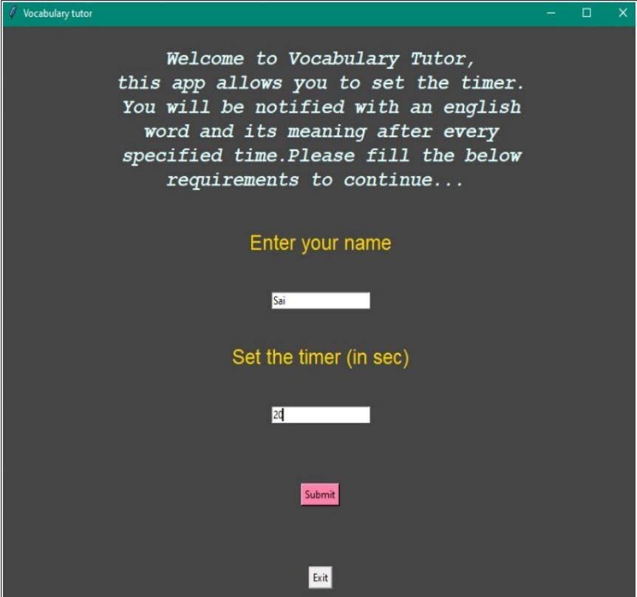

Fig 5.2.3

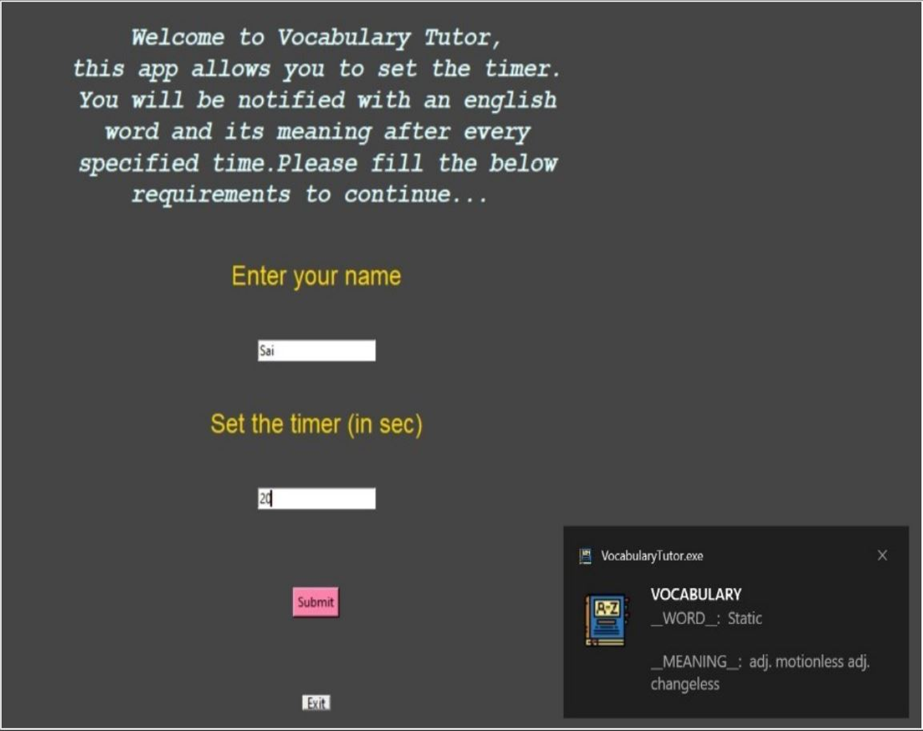**5.2.3 Resultant POP out**

Fig 5.2.4

## CHAPTER 6

## CONCLUSION AND FUTURE WORK

### 6.1 Conclusions:

The Vocabulary Tutor application works as a remainder which displays a new word and its meaning after every specified time by the user. As many people now a days are using laptops, mobile phones, etc., This application will be especially useful in Developing the vocabulary of the users.

### 6.1.1 Future works:

As this application was made only for Desktops, laptops will try to develop the similar application which will be available for android users as well. And also, will try to add new features and better vocabulary as well.

## 6.2 References

* <https://github.com/gst1919/Vocabulary-Tutor.git>
* <https://www.tutorialspoint.com/python/>
* <https://pypi.org/project/pyinstaller/>
* <https://drive.google.com/file/d/1E69J1Jh25Od1ZuR90C3ZWgttOQZlRjZT/view?usp=sharing>
* <https://www.researchgate.net/publication/350960189_Using_Realia_to_Improve_English_Vocabulary_at_Primary_Level>
* https://www.researchgate.net/publication/343252325_Effective_English_vocabulary_learning_strategies_A_research_summary